Fund User Types

CapHive enables differentiated access rights for users of the Fund linked to the roles.

There are 3 categories of users:

- Company Admin
  - Access to all modules, including investors and documents
  - Access to all funds. Deals etc
  - Full access including Create, Update and Delete
  - Does not have Approval access by default
  - Can change the access rights for other users / Advisors of the Entity

- Approver
  - Approval ability
  - Approver role has to be given in conjunction with the Company Admin / Employee role

- Employee
  - Does not get any access to investors / modules by default
  - Has specific access which is defined by the Company Admin through the Home icon on the top right of the screen
  - Giving Access to Funds / Deals will enable the respective module, however access for specific funds / deals will need to given separately
  - Access to specific Funds / Schemes will need to be given through the tab for ‘Access Rights’ inside the respective Fund(s)
    - Access can be defined for Read Only / Create / Update / Delete

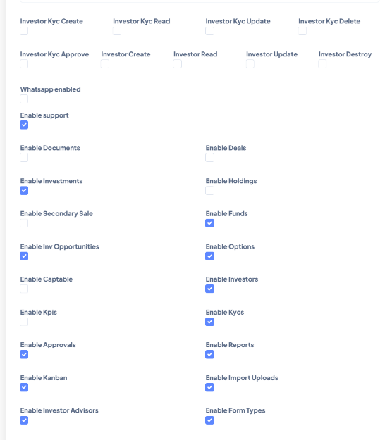
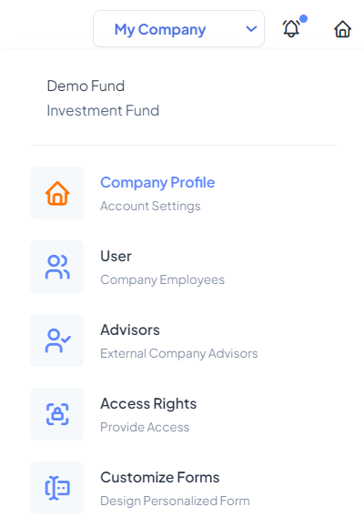

Adding access for an Employee for a specific fund:

- Click on the tab for Access inside the relevant fund

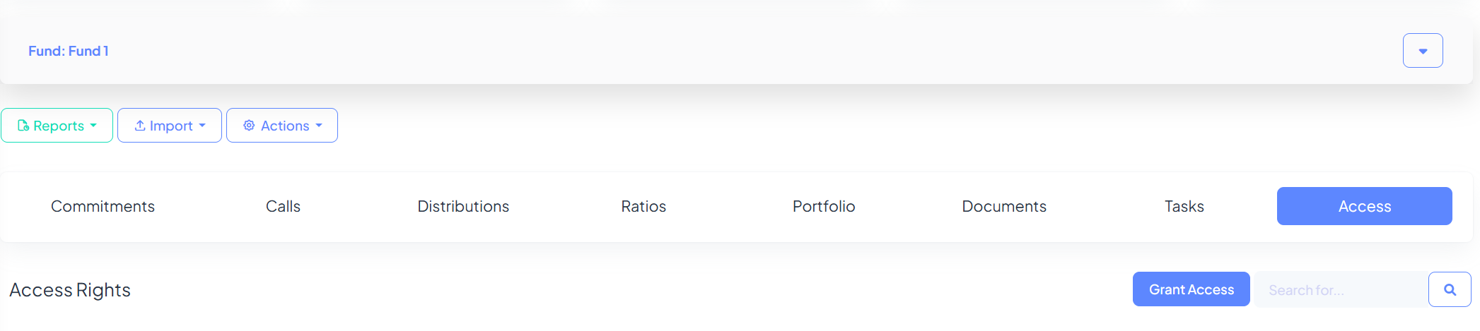

- Add the Access right
- Select the option for Employee in Access type
- Select the relevant Employee from the dropdown list
- Checkbox the relevant permissions
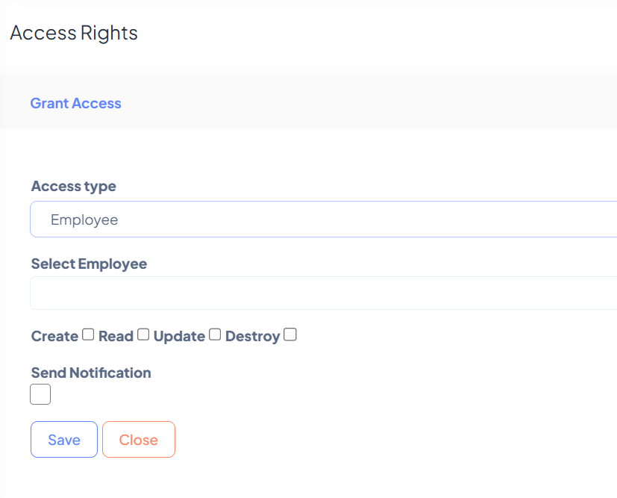

- Advisor Access
- Advisors are third party entities who may be given roles equivalent to an ‘Employee’ i.e. they can have full or limited access to relevant sections of the platform. However, they cannot be granted Admin access
- Advisors will be able to switch between different entities with the same email address
- The Process flow for advisors is the same as for employees – with selecting the option for Advisor instead of Employee.

